Project Design Phase-I - Solution Fit Template

Project Title: Team ID:PNT2022TMID03607

Corporate Employee Attrition Analytics

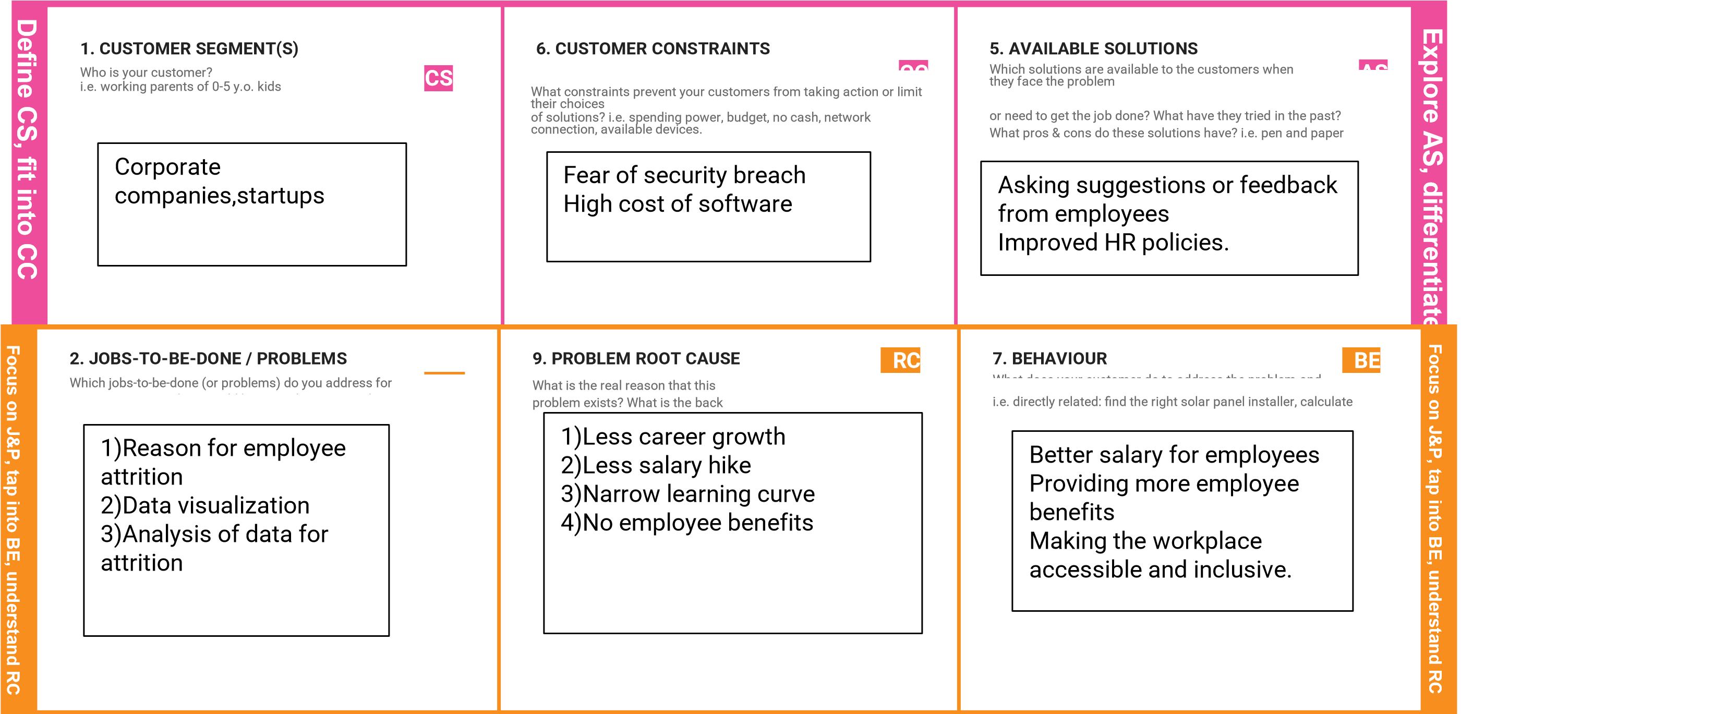

|  |  |  |  |  |  |  |  |  |  |  |
| --- | --- | --- | --- | --- | --- | --- | --- | --- | --- | --- |
|  |  | | |  | | |  | | |  |
| 3. TRIGGERS | TR |  | 10. YOUR SOLUTION | SL |  | 8. CHANNELS of BEHAVIOUR | CH |  |
| What triggers customers to act? i.e. seeing their neighbour installing | |  | If you are working on an existing business, write down your current solution first, | |  | 8.1 ONLINE | | |
| solar panels, reading about a more efficient solution in the news.     |  | | --- | | Better performance of other companies,loss of talented folks | | |  | fill in the canvas, and check how much it fits reality.  If you are working on a new business proposition, then keep it blank until you fill in the canvas and come up with a solution that fits within customer limitations, solves a problem and matches customer behaviour.       |  | | --- | | Collect data about employees and visualise and analyse the  data as to why the attrition is happening | | |  | What kind of actions do customers take online? Extract online channels from #7    8.2 OFFLINE  What kind of actions do customers take offline? Extract offline channels from #7 and use them for customer development.   |  | | --- | | 1)ONLINE  Provide various benefits like work from home to employees.  2)OFFLINE  Makes the working space to be employee friendly. | | | |
| 4. EMOTIONS: BEFORE / AFTER EM  How do customers feel when they face a problem or a job and afterwards?  i.e. lost, insecure > confident, in control - use it in your communication strategy & design     |  | | --- | | BEFORE:  Confused, unmotivated, less  productive AFTER:  Secure, more productive, happy | | | . |



I

d

e

n

ti

f